BookNest: MERN Stack Online Bookstore Platform

Project Description:
BookNest is a full-stack online bookstore built on the MERN stack (MongoDB, Express, React, Node.js) that lets readers browse a curated catalog, search and filter by title, author, or genre, and purchase books through a persistent shopping cart and checkout flow. The platform includes a Book Catalog module that lists titles with cover images, pricing, and stock status; a Cart & Checkout module that lets registered users add, update, and remove items before placing an order; and an Admin Dashboard that gives store administrators full CRUD control over the book inventory and visibility into incoming orders.
User accounts are secured with JWT-based authentication, with role-based access separating regular shoppers from admin users. The backend exposes a RESTful API built with Express and Mongoose, backed by a MongoDB Atlas cluster for persistence. The React frontend consumes this API through Axios, manages authentication and cart state client-side, and is styled as a responsive single-page application. Environment configuration is handled via .env files on both client and server, keeping API URLs, database connection strings, and JWT secrets out of source control. Together, these modules give shoppers a fast, reliable browsing-to-checkout experience while giving administrators the tools to keep the catalog current.

Scenarios
Scenario 1: A first-time visitor lands on the home page, browses the catalog by genre, and searches for "science fiction." They open a book's detail page to read the description and check stock, add it to their cart, then register an account to complete checkout, after which the order appears in their order history.
Scenario 2: A returning customer logs in, revisits their cart where previously added items have persisted, updates the quantity on one item, removes another, and proceeds to checkout. The system validates stock availability before confirming the order and decrements inventory accordingly.
Scenario 3: An administrator logs in with an admin account and is routed to the Admin Dashboard. They add a newly released title with a cover image and price, edit the stock count on an existing book that sold out, and review the list of recent orders to confirm fulfillment status.

Technical Architecture:
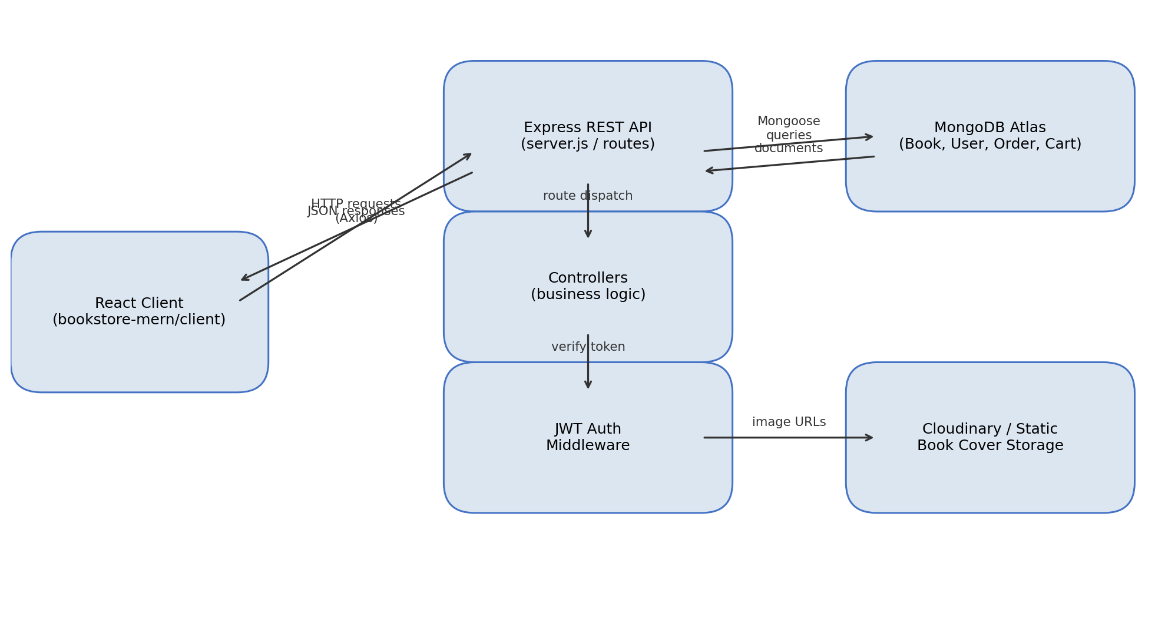
Description: BookNest follows a classic three-tier MERN architecture. The React client renders the catalog, cart, and admin views, and communicates with the backend exclusively over a versioned REST API using Axios. The Express server routes incoming requests to controllers that encapsulate business logic (catalog queries, cart calculations, order placement), while a JWT auth middleware protects user- and admin-only routes by verifying tokens issued at login. Mongoose models define schemas for Book, User, Cart, and Order documents and mediate all reads/writes to the MongoDB Atlas cluster. Book cover images are served either from a cloud image host (e.g., Cloudinary) or a static /uploads folder, referenced by URL in the Book document.
(Note: Since this project uses a database, an ER diagram describing the Book, User, Cart, and Order collections and their relationships should be added alongside this architecture diagram.)

Pre-requisites:
- Node.js & npm Knowledge: Node.js Documentation
- Express.js Familiarity: Express Documentation
- MongoDB & Mongoose: MongoDB Documentation, Mongoose Documentation
- React Fundamentals: React Documentation
- HTML, CSS, and JavaScript Skills: MDN Web Docs
- Version Control with Git: Git Documentation
- JWT Authentication Concepts: jsonwebtoken (npm) Documentation
- MongoDB Atlas Setup: MongoDB Atlas Getting Started Guide

Project Workflow:

Milestone 1: Planning and Architecture
Activity 1.1: Create a MongoDB Atlas cluster, configure network access and a database user, and copy the connection string.
Activity 1.2: Design the data models for Book, User, Cart, and Order, defining fields, types, and relationships (e.g., Order referencing User and an array of Book line items).
Activity 1.3: Define the application architecture, detailing how the React client, Express API, and MongoDB layer interact, and where authentication fits in the request lifecycle.
Activity 1.4: Set up the development environment: initialize separate client and server npm projects, install core dependencies, and agree on the folder structure.

Milestone 2: Backend Development

Activity 2.1: Build Mongoose Models
Define schemas for each collection under server/models:
// models/Book.js
const bookSchema = new mongoose.Schema({
title: { type: String, required: true },
author: { type: String, required: true },
genre: String,
price: { type: Number, required: true },
stock: { type: Number, default: 0 },
coverImage: String,
description: String,
}, { timestamps: true });
- User.js: name, email, hashed password, role ("user" | "admin").
- Cart.js: user reference and an array of { book, quantity } items.
- Order.js: user reference, ordered items snapshot, total, status, and timestamps.

Activity 2.2: Implement Authentication & Authorization
- Build /api/auth/register and /api/auth/login routes; hash passwords with bcrypt and issue a signed JWT on successful login.
- Write an authMiddleware.js that verifies the Authorization: Bearer <token> header and attaches the decoded user to req.user.
- Add an adminOnly middleware that checks req.user.role === "admin" before allowing access to inventory-management and order-management routes.

Activity 2.3: Build REST API Endpoints
GET /api/books - list/search/filter books
GET /api/books/:id - get single book details
POST /api/books - (admin) create a book
PUT /api/books/:id - (admin) update a book
DELETE /api/books/:id - (admin) delete a book
GET /api/cart - (auth) get current user's cart
POST /api/cart - (auth) add/update an item in the cart
DELETE /api/cart/:bookId - (auth) remove an item from the cart
POST /api/orders - (auth) place an order from the cart
GET /api/orders/mine - (auth) list current user's orders
GET /api/orders - (admin) list all orders

Milestone 3: Server Entry Point & Middleware
Milestone 3 focuses on wiring the routes, middleware, and error handling together in server.js, which serves as the backbone of the BookNest API.

Activity 3.1: Configure the Express Application
const express = require('express');
const mongoose = require('mongoose');
require('dotenv').config();

const app = express();
app.use(express.json());
app.use(require('cors')());

app.use('/api/auth', require('./routes/authRoutes'));
app.use('/api/books', require('./routes/bookRoutes'));
app.use('/api/cart', require('./routes/cartRoutes'));
app.use('/api/orders', require('./routes/orderRoutes'));

app.use(require('./middleware/errorHandler'));

mongoose.connect(process.env.MONGO_URI).then(() => {
app.listen(process.env.PORT || 5000, () =>
console.log('Server running on port', process.env.PORT || 5000)
);
});
- Centralize error responses in errorHandler.js so every route returns a consistent { error } JSON shape.
- Load configuration (Mongo URI, JWT secret, port) from .env using dotenv, keeping secrets out of source control.

Milestone 4: Frontend Development
Milestone 4 focuses on building a responsive, component-driven React interface for browsing, cart management, and the admin dashboard, and wiring it to the backend API.

Activity 4.1: Application Structure & Routing
- Set up React Router with routes for Home, Book Details, Cart, Login, Register, and an admin-protected /admin section.
- Create a PrivateRoute / AdminRoute wrapper component that redirects unauthenticated or non-admin users away from protected pages.

Activity 4.2: Build UI Components
- Navbar: shows the site logo, search bar, cart item count, and login/account controls.
- BookCard / BookList: displays cover image, title, author, price, and an "Add to Cart" action for each catalog item.
- Cart page: lists cart items with quantity controls, a running subtotal, and a checkout button.
- AdminDashboard: a table view for managing books (add/edit/delete) and a read-only list of recent orders.

Activity 4.3: Connect to the API
- Create an Axios instance (services/api.js) with the backend base URL from REACT_APP_API_URL, and an interceptor that attaches the stored JWT to outgoing requests.
- Manage authentication state and cart state via React Context (AuthContext, CartContext) so login status and cart contents are available across components.
- On checkout, POST the cart to /api/orders, clear the client-side cart on success, and redirect to an order confirmation view.

Milestone 5: Deployment
Milestone 5 covers preparing BookNest for local verification and then deploying the frontend and backend so the application is publicly accessible.

Activity 5.1: Prepare the Application
- Set NODE_ENV, MONGO_URI, JWT_SECRET, and PORT in the server's .env file.
- Set REACT_APP_API_URL in the client's .env file to point at the backend's URL.
cd server && npm install
cd ../client && npm install

Activity 5.2: Local Testing and Verification
# terminal 1
cd server && npm run dev # starts Express on http://localhost:5000

# terminal 2
cd client && npm start # starts React on http://localhost:3000
- Walk through each scenario end-to-end locally: register, browse, add to cart, checkout, and verify order history; then log in as an admin to confirm CRUD operations on the catalog and visibility into orders.

Activity 5.3: Public Deployment
- Push MONGO_URI, JWT_SECRET, and any image-storage credentials as environment variables in the hosting provider's dashboard rather than committing them.
- Deploy the Express API to a Node-friendly host (e.g., Render or Railway); note the resulting public API URL.
- Deploy the React build to a static host (e.g., Vercel or Netlify), setting REACT_APP_API_URL to the deployed API URL before building.
- Confirm CORS on the server allows requests from the deployed frontend's origin.

Important Notes:
- Never commit .env files; provide a .env.example with placeholder keys for both client and server.
- JWT tokens should have a reasonable expiry, and the client should handle 401 responses by redirecting to login.
- Validate stock server-side at checkout time to prevent overselling if two users order the last copy simultaneously.

Exploring the Website's Web Pages:

Home / Catalog Page:
The landing page displays the book catalog in a responsive grid, with a search bar and genre filters in the navbar. Each book card shows its cover, title, author, price, and stock status, with an "Add to Cart" button.

Book Details Page:
Reached by clicking a catalog item, this page shows the full description, price, and stock for a single book, along with quantity selection and an "Add to Cart" action.

Cart Page:
Lists all items currently in the user's cart with editable quantities, a per-item and running subtotal, and a "Proceed to Checkout" button that creates the order.

Login / Register Pages:
Simple forms for account creation and authentication; on success, the issued JWT is stored client-side and the user is redirected to the page they came from.

Admin Dashboard:
Accessible only to users with the admin role, this page provides a table of all books with inline edit/delete actions, a form to add new titles, and a read-only list of recent orders for fulfillment tracking.

Conclusion:
BookNest is a full-stack MERN application that streamlines the path from book discovery to purchase. It combines a searchable catalog, persistent cart, and secure JWT-based checkout on the shopper side with a role-protected admin dashboard for inventory and order management. Built with Express and MongoDB Atlas on the backend and a componentized React frontend, the project demonstrates a complete, production-shaped e-commerce workflow with room to grow. Looking ahead, BookNest offers clear opportunities for expansion, such as integrating a real payment gateway, adding user reviews and ratings, wishlist functionality, and order-status notifications. By continuing to refine the API contracts and frontend UX, the platform is well-positioned to evolve from a course project into a genuinely usable bookstore application.

